|  |  |
| --- | --- |
| **Name** | Manish Shashikant Jadhav |
| **UID** | 2023301005 |
| **Subject** | Software Engineering |
| **Experiment No.** | 7 |
| **Aim** | Implementation |

* **Login Page:**

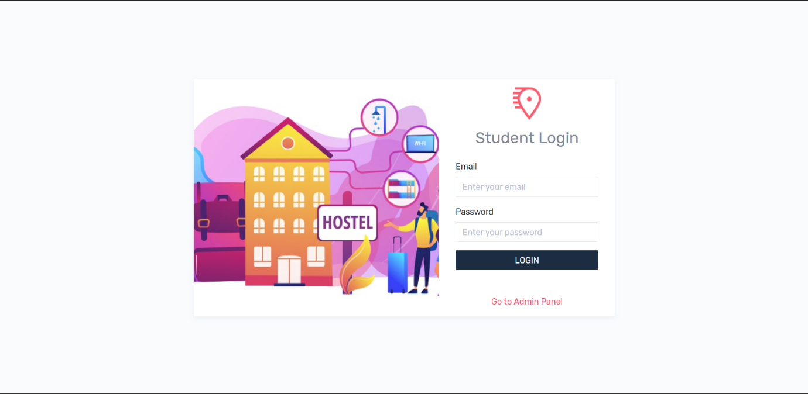

* Admin Side:

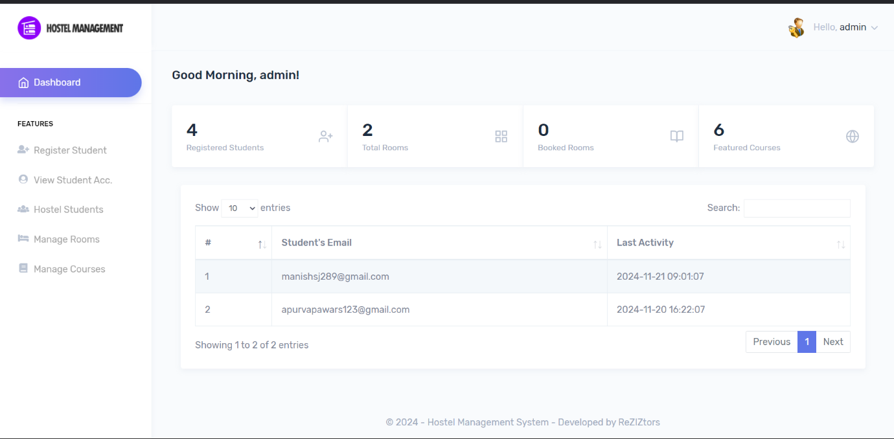

* Student Registration Form:

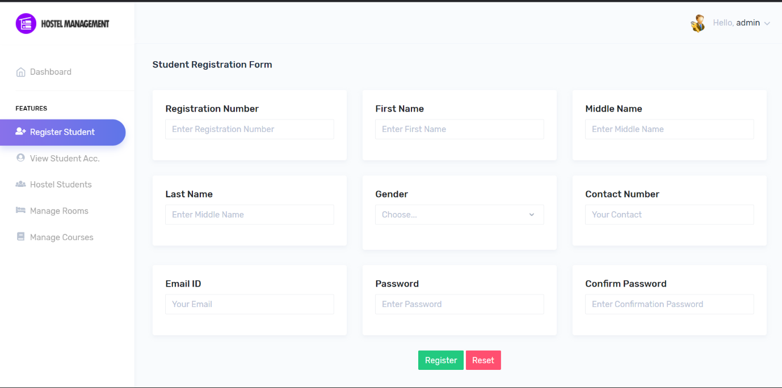

* View Student Account:

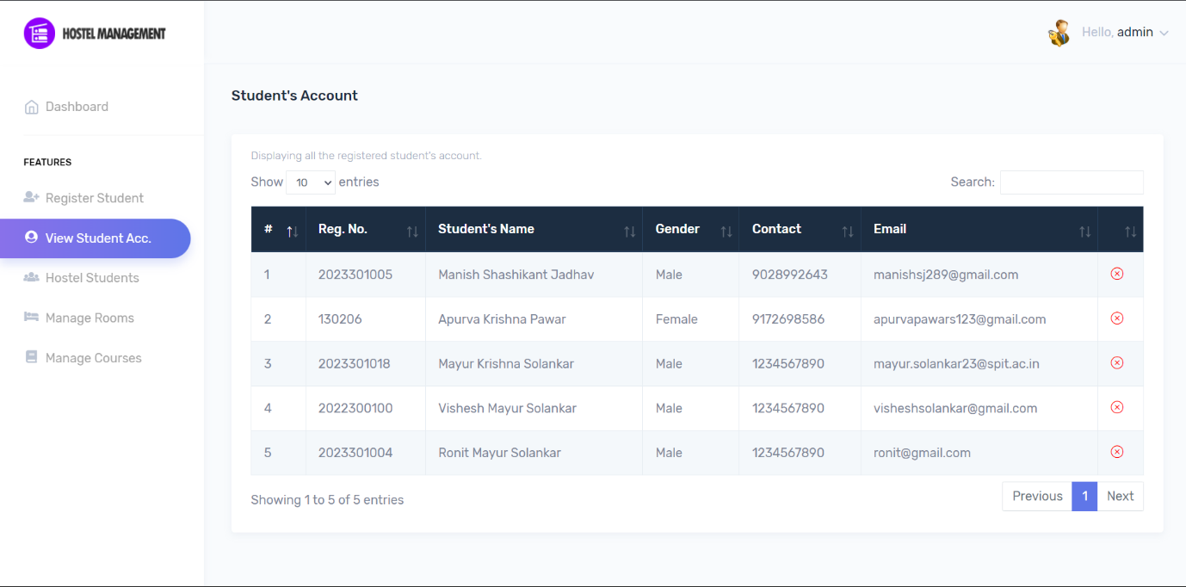

* Add/Manage Rooms:

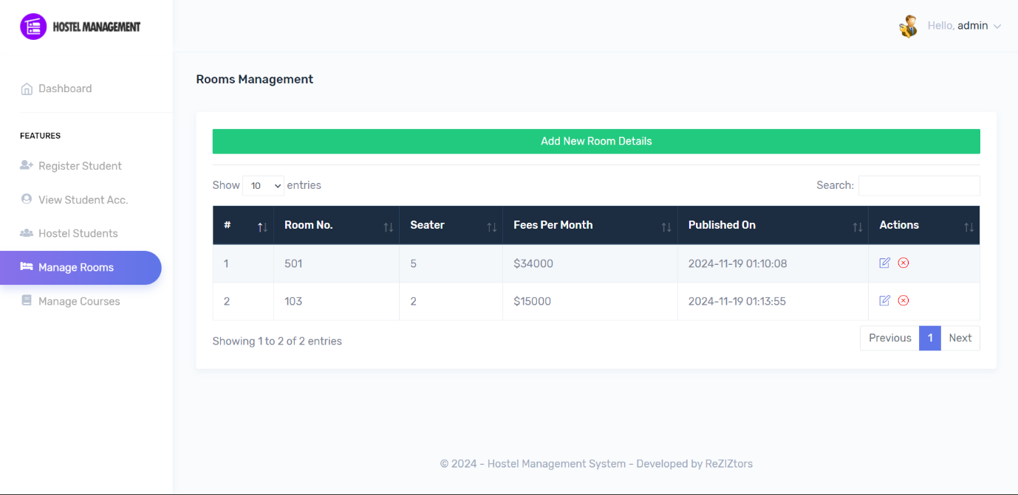

* Add rooms:

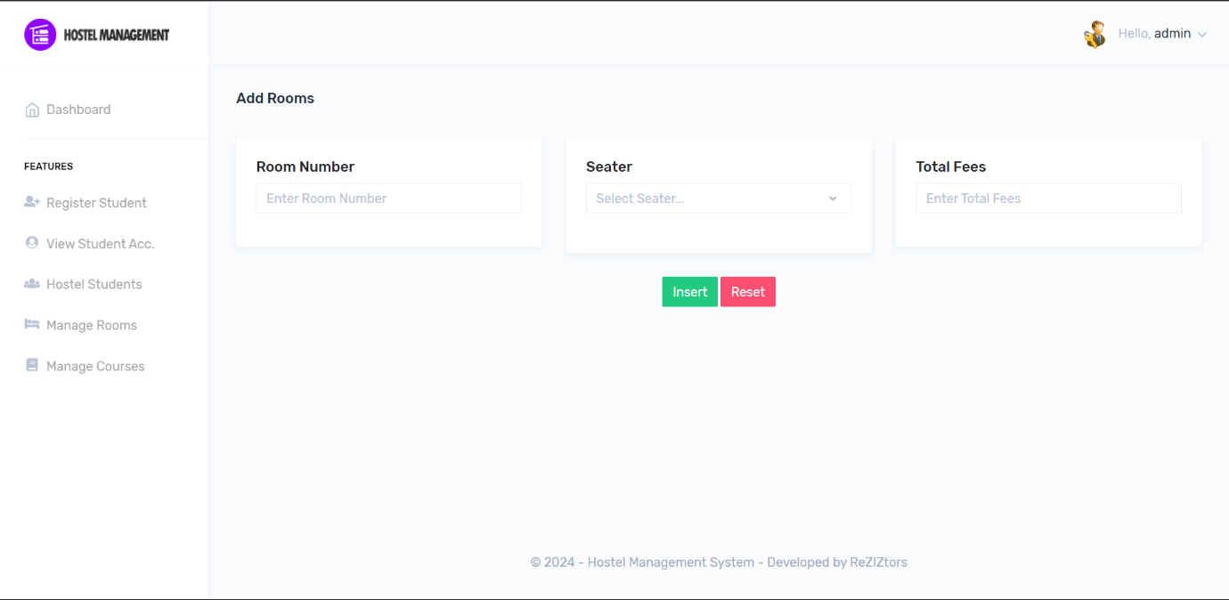

* Add/Manage Course:

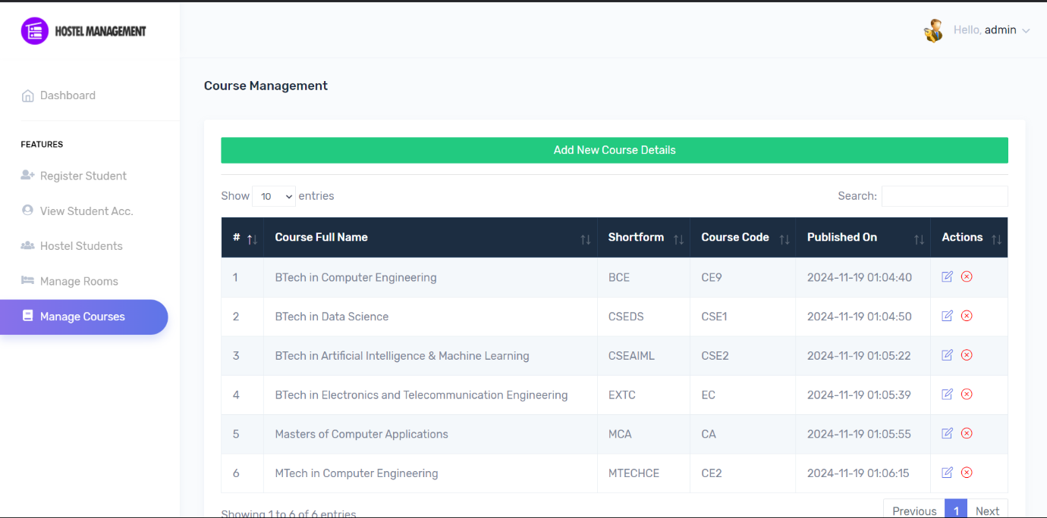

* Client Side:

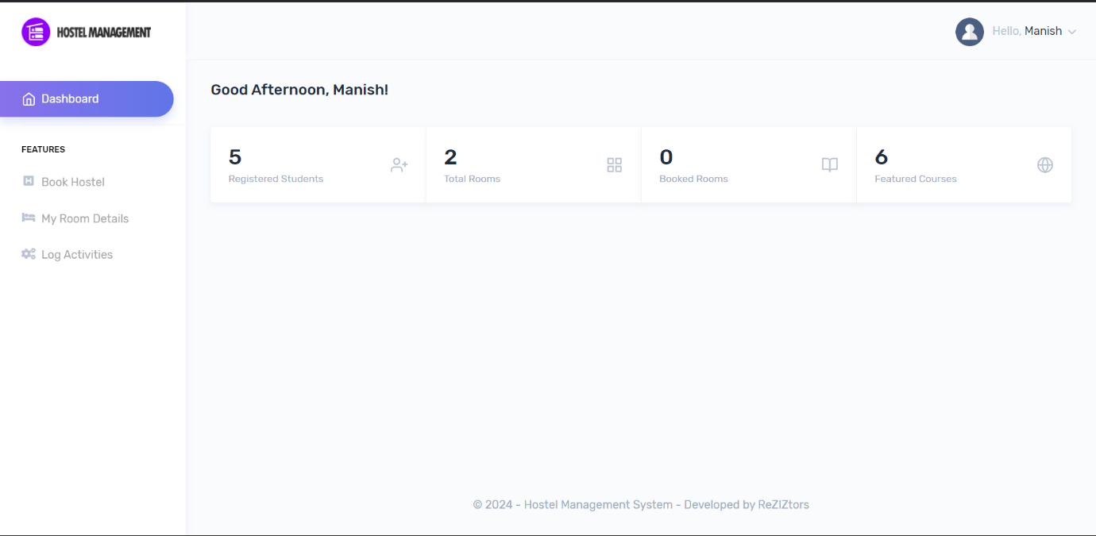

* Book Hostel:

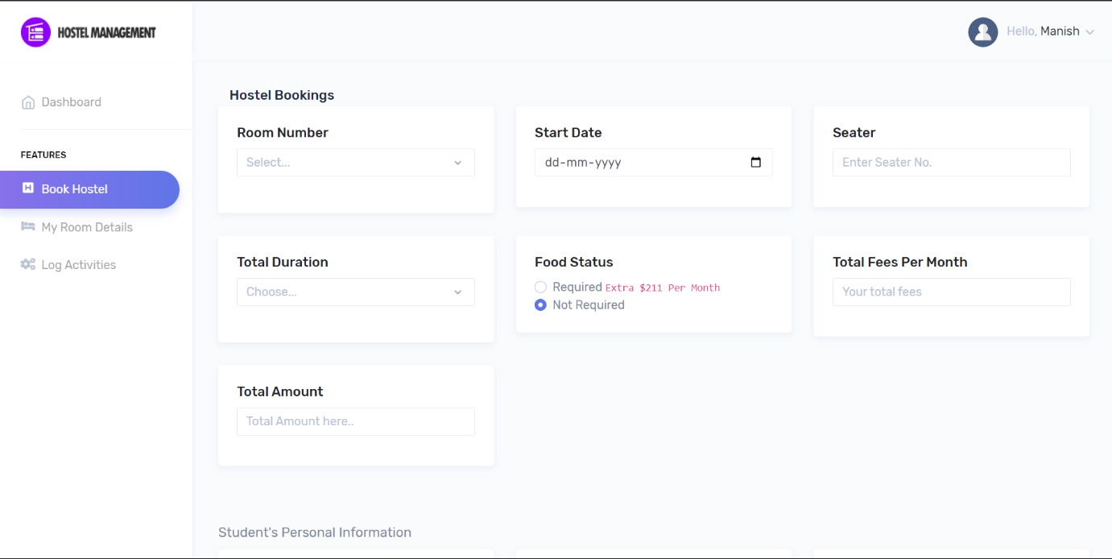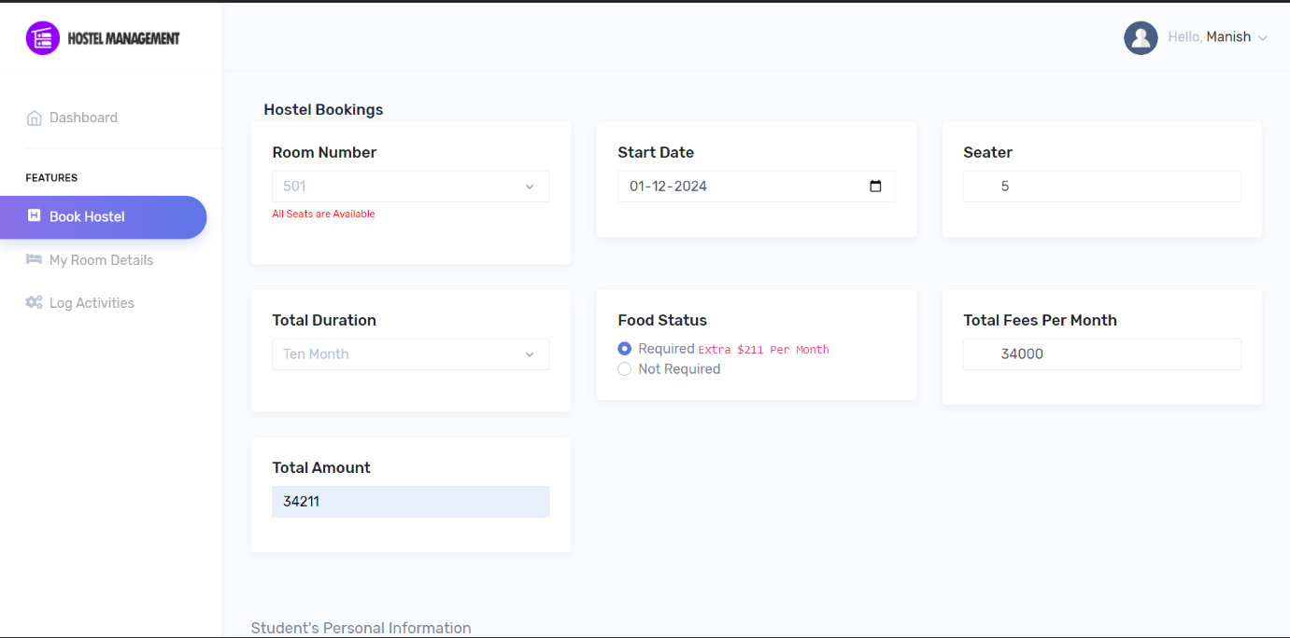

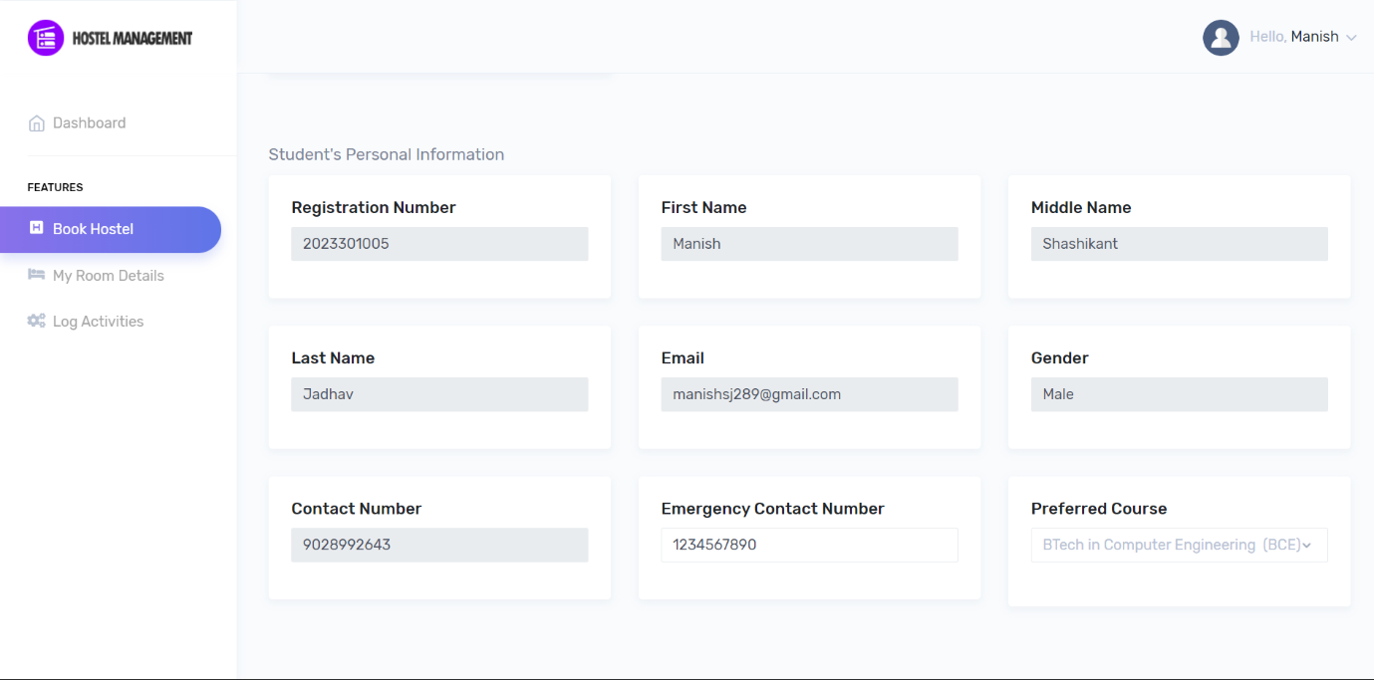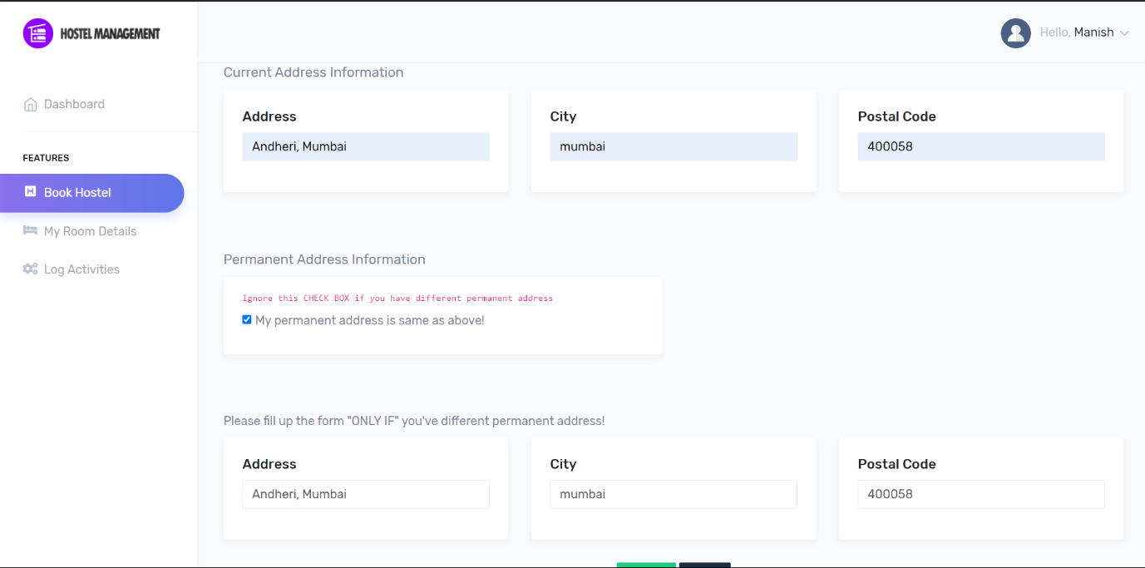

* View room details:

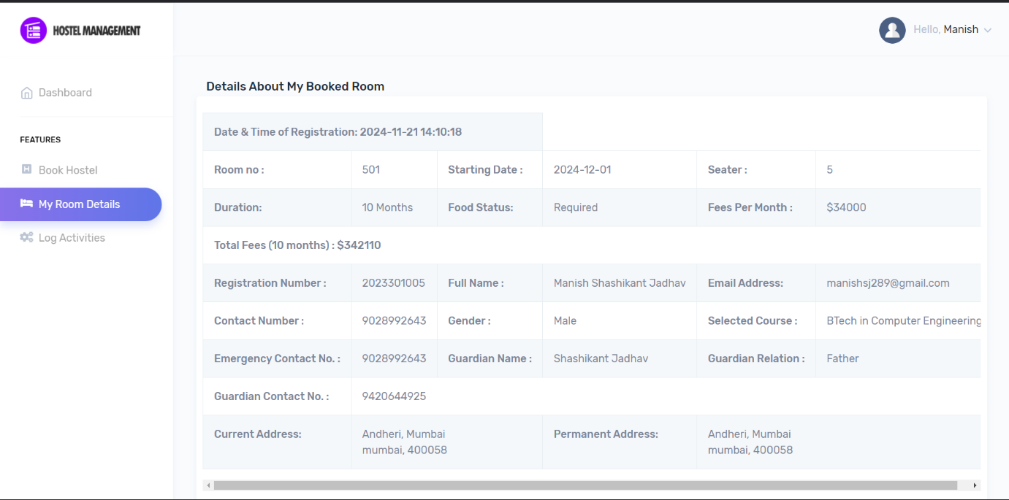

* Hostel Registered Students list:

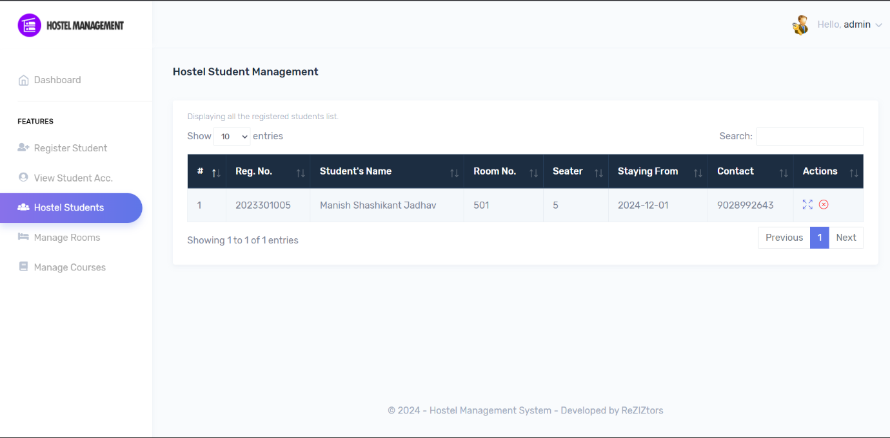

|  |  |
| --- | --- |
| **Conclusion** | Hence by completing this experiment we have implemented the website made using PHP and MySql |